7.CREDIT CARD PROCESSING SYSTEM

SEQUNCE DIAGRAM

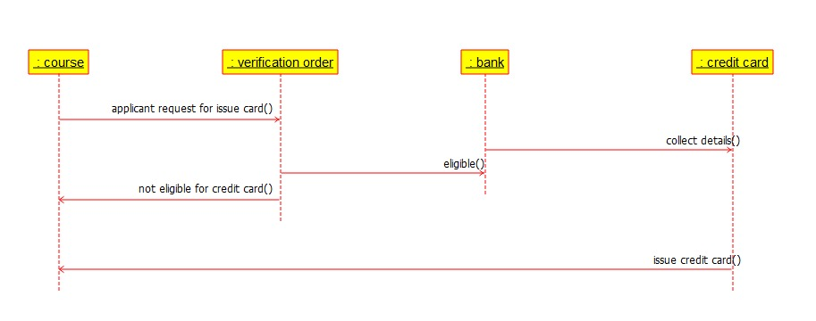

DEPLOYMENT DIAGRAM

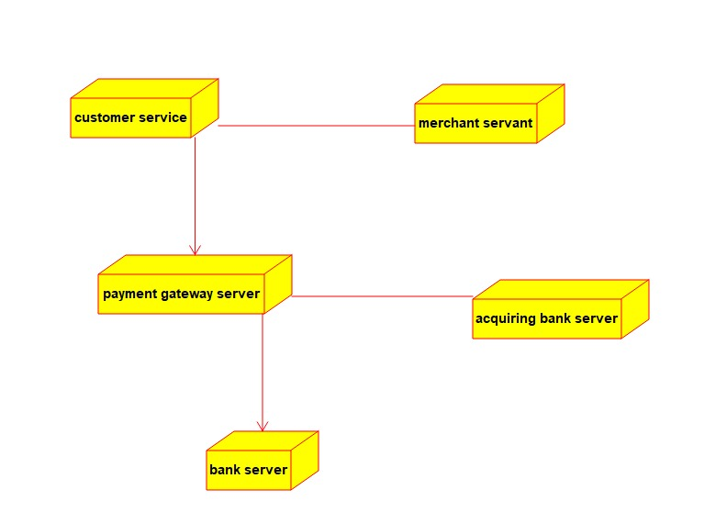

STATE CHART DIAGRAM

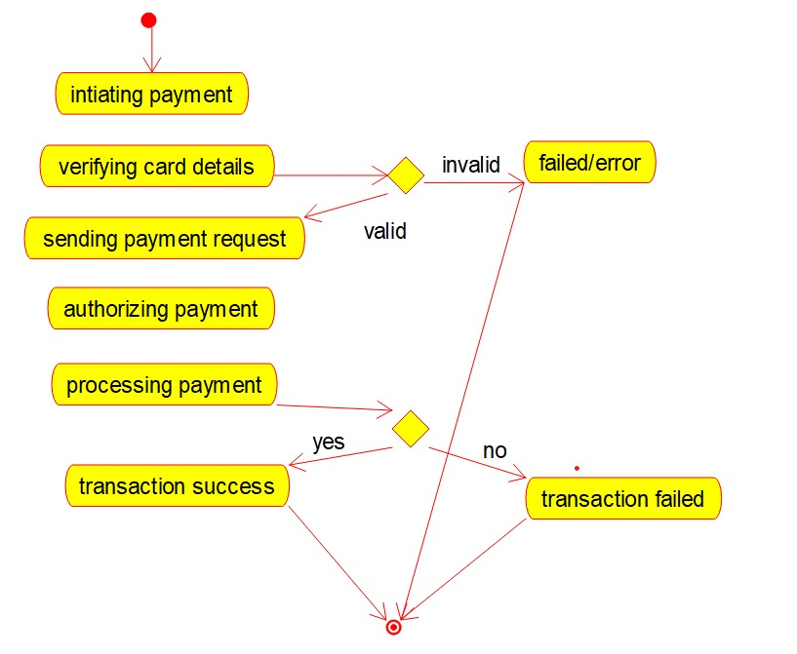

USECASE DIAGRAM

